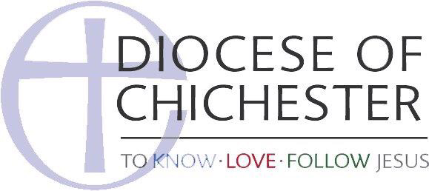

St Mary’s Church Policy on the Safeguarding of Adults in the Church

This statement was adopted by St Mary’s Church, Pulborough at a PCC meeting on 14 April 2024.

This policy will be reviewed annually by the PCC and a report given to the Annual Parochial Church Meeting by the parish representative in order that the policy might be monitored.

- We recognise that everyone has different levels of vulnerability and that each of us may be regarded as vulnerable at some time in our lives.
- As members of this parish we commit ourselves to respectful pastoral care for all adults to whom we minister.
- We commit ourselves to the safeguarding of people who may be vulnerable, ensuring their well-being in the life of this church.
- We commit ourselves to promoting safe practice by those in positions of trust.
- The parish commits itself to promoting the inclusion and empowerment of people who may be vulnerable.
- It is the responsibility of each of us to prevent the physical, verbal, emotional, financial, sexual, institutional and spiritual abuse of vulnerable people and to report any such abuse that we discover or suspect to the Rector The Reverend Canon Paul Seaman or Austen Hindman.
- We undertake to exercise proper care in the appointment and selection of those who will work with people who may be vulnerable, including the request for a DBS (Disclosure and Barring Service) clearance when required, to be processed by our parish CCPAS Lead Recruiter, Alyson Heath.
- The parish is committed to supporting, resourcing, training and regularly reviewing those who undertake work amongst people who may be vulnerable.
- The parish adopts the guidelines of the Church of England and the Diocese.
- Each person who works with vulnerable people will agree to abide by these recommendations and the guidelines established by this church.

This church appoints:

Austen Hindman

26 Oddstones, Pulborough, West Sussex, RH20 1FS
01798-669102
ajh75@hotmail.com
to represent the concerns and views of vulnerable people at our meetings and outside bodies.

Our CCPAS Lead Recruiter is Alyson Heath

Rector: The Reverend Canon Paul Seaman -
Churchwardens Alyson Heath – , Ann Kaiser –

